Introduction:
In this workshop, we will conduct experiment to measure capacitors, and learn the factors that affect the capacitances of capacitors. We use the simulator below to conduct virtual experiment:
https://phet.colorado.edu/en/simulations/capacitor-lab
Theory:
Experiments show that the capacitance of a parallel plate capacitor is:
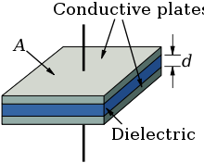 $C=\frac{\text{ε}\text{.A }}{d}$
Where ε = permittivity of the separating material inside the capacitor
A = area of the plates
D = distance between the plates

Methodology:
Click on https://phet.colorado.edu/en/simulations/capacitor-lab
Choose “Run CheepJ Browser-Compatible Version”, tick “Voltmeter”, “Plate Charge”, and “Capacitance” in the top right “Meters” section, and “Plate Charges” in the “View” section.
Move the red and black probes of the voltmeter so that the red probe touch the upper place and black probe touch the lower plate. This will give you voltage readings on the voltmeter. For example, you should see the display like this:
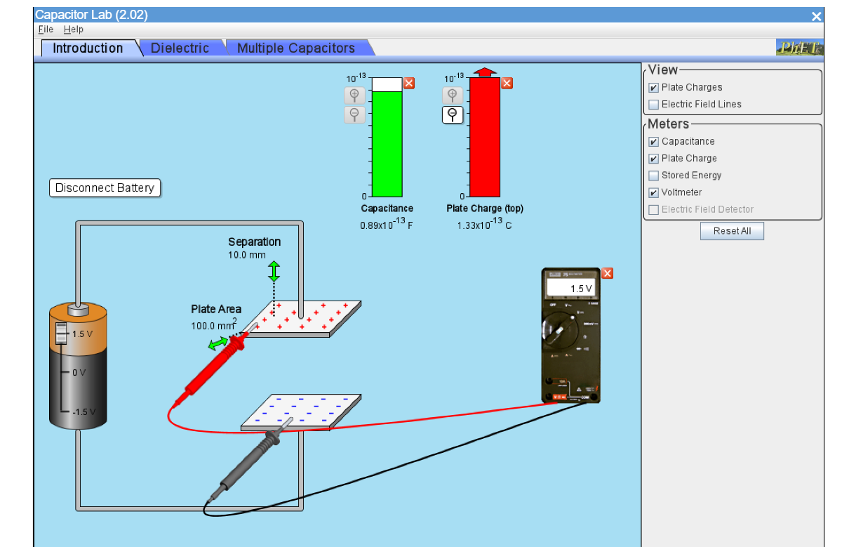
Part 1: Capacitance and Area C=↋₀A/d:
In this part the distance, d, between the plates is kept constant d= 10x10⁻³m and the area of the plates is changed. You are to record the values for area (in m²) and the capacitance C (in F). Take at least six values of A and C, and then fill the table below:
d= 10x10⁻³ m
A (m²) | C (F)

  - Use Excel to plot the relationship between A and C, and draw the best straight-line:

  - Determine its gradient:

  - From the slope, determine the value of the permittivity of free space ↋_{ᵒ}

  - Determine the percentage error using the real value ↋_{ᵒ}=8.85X10⁻¹² C²/N.m²

Part 2: Capacitance and Distance C=↋₀A/d:
In this part the area, A, of the plate is kept constant A= 100x10⁻⁶ m² and the distance d between the plates is changed. You are to record the values for distance (in m) and the capacitance C (in F). Take at least six values of d and C, and then fill the table below by calculating (1/d):
A= 100x10⁻⁶ m²

d (m) | 1/d ( m⁻¹) | C (F)

  - Use Excel to plot the relationship between (1/d) and C, Draw the best straight-line

  - Determine its slope.

  - From the slope, determine the value of the permittivity of free space ↋_{ᵒ}

2.4 Determine the percentage error using the real value ↋_{ᵒ=} 8.85X10⁻¹² C²/N.m²

Part 3: Capacitance and Charge and Voltage Q = CV:
In this part the area, A and distance d will be kept as the default values. This should give a capacitor of C=0.89x10⁻¹³F. Change the value of the power supply V, then record the values for the charge Q (in C) and the potential difference V ( in V).
3.1 Record V (in V) and Q (in C) in the following table:
Capacitance real from PhET (0.89x10⁻13)F

V(Volts) | Q(C)

3.2 Use Excel to plot the relationship between V and Q, draw the best fit straight-line

.
3.3. Determine its slope:

3.4 From the slope, determine the value of C (in F)

3.5 Calculate the percentage error in your result:

Part 4: Energy Stored on a Charged Capacitor E = CV²/2:
In this part the area, A and distance d will be kept as the default values. This should give a capacitor of C=0.89x10⁻¹³F. You will need to tick the “Stored Energy” from the “Meters” section. Change the value of the power supply V, then record the values for the stored energy E (in J) and the potential difference V ( in V).
4.1 Record V (in V) and Q (in C) in the following table:
Capacitance real from PhET (0.89x10⁻13)F

V(Volts) | E (J)

4.2 Use the method you learnt in part 3, calculate the capacitance of this capacitor from the relationship between the V – E readings in 4.1, and calculate the error rate of your method.

.

