Introduction:
In this worksheet, you will be guided to explore the simulation and verify the nature of the Hooke’s Law.

Theory:

The restoring force F of a stretched spring is given by Hooke's Law:
F = -kΔx
where Δx is the amount of stretch (ie extension), the minus indicates that the restoring
force is opposite to the extension and k is the spring constant (units Nm⁻¹).

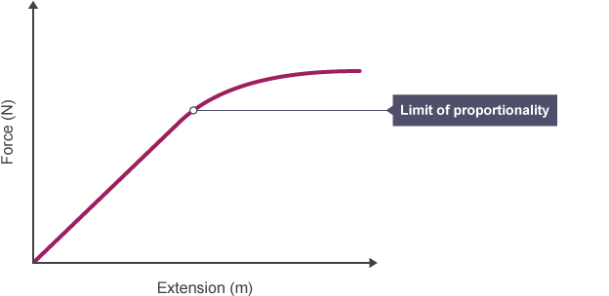
Hooke's law states that the force a spring exerts is proportional to its extension. As long as not stretched or compressed beyond their elastic limit.

Methodology:
  - Open the simulator window: https://bit.ly/massnspring
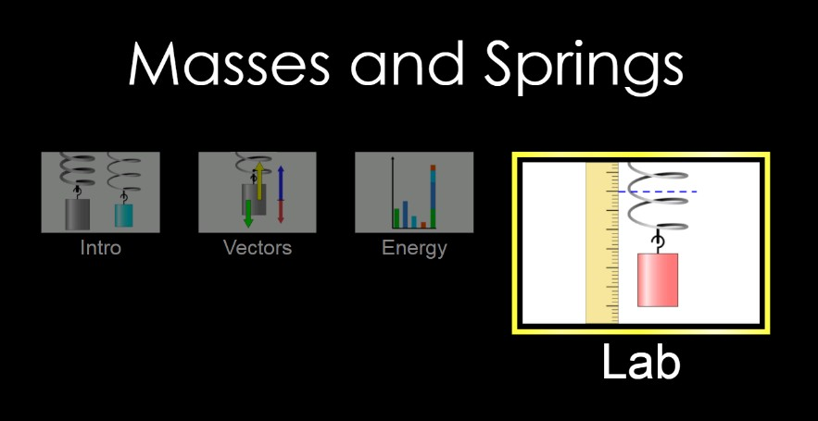
  - Select the “Lab” tab

  - (1) Enable the ‘Movable Line’; (2) Set the Damping (friction) to ‘Lots’; (3) Drag the ruler out (See below diagram)
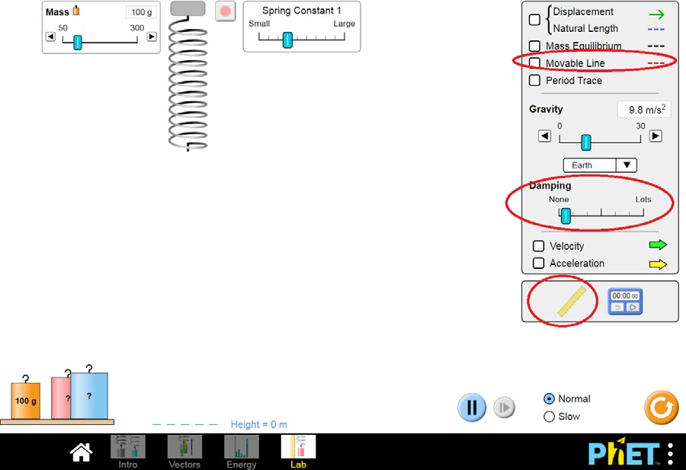
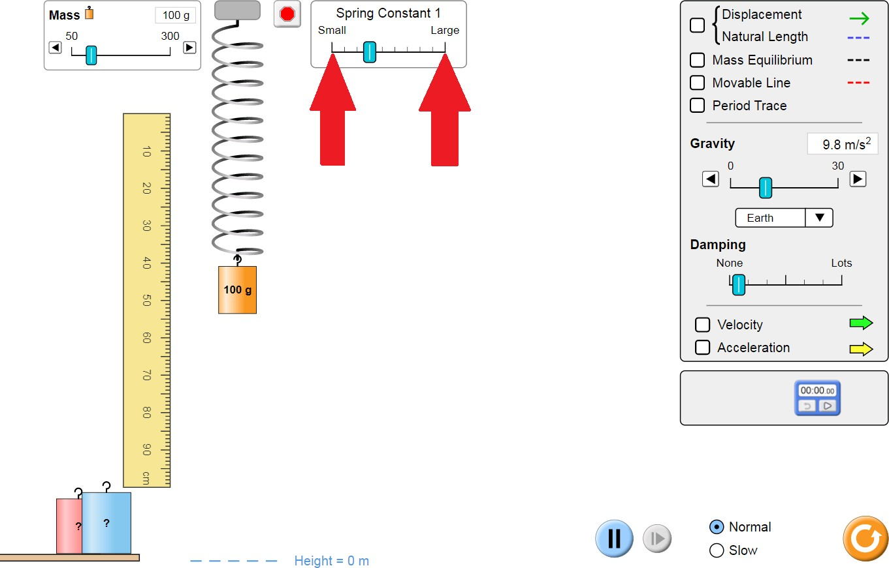
  - In this section, we would investigate and estimate the magnitude of the smallest and largest spring constant available (as indicated by red arrows above) :
  - Adjust the spring constant to the smallest (most left option), i.e. the thinnest spring
  - Measure the original length of the spring with the ruler
  - Hang the 100g mass on the spring and wait until the spring stops moving
  - Measure the new total length of the spring
  - Repeat the experiment with different magnitude of force by changing the magnitude of mass. Collect at least 7 different sets of data. Fill the raw data table below:
Mass/g | Original length/cm | Total length/cm
100 | 4.5
150
80
60
50
120
130
Table 1. Raw data for the thinnest spring

  - Now, repeat the same procedures for the largest spring constant (most right option). Fill in the table. Note you don’t have to use the weighs of the same masses as used for the thin spring.

Mass/g | Original length/cm | Total length/cm
50 | 4.5
80
120
150
200
250
300
Table 2. Raw data for the thickest spring

  - Process the data from Table 1 and Table 2 to Table 3 by:
- calculating the extensions by subtracting total length with original length
- calculating the tension, which is the same as weight in this experiment by the equation W = mg
Tension/N | Extension of the Thin Spring /cm | Extension of the Thick Spring/cm

Table 3. Processed data for both springs

  - In Excel draw the graphs of Extension against Tension for both springs.

  - Calculate the slopes (gradients) for both graphs. You can also let Excel to come up with gradients following the steps:
- Click the graph you will see a “+” icon appears at the right-hand side.
- Click the + sign and click “Trendline”, you will see a best fitting line
- Click the trendline, right click your mouse, choose “Format Trendline”, then scroll down to the bottom and choose “Display Equation on Chart”.

Further Questions
- State and explain the physical meaning of the slope.

- Did the spring reach limit of proportionality? How do you know? Using the graph, find the spring constant of both springs.

- What is the mass of the unknown Red block? Describe and show how you find it.
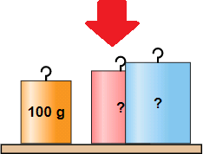
Use thick spring, the thing one will be too long to measure.

