Introduction:
In this workshop, we will continue to conduct experiment with capacitors. We will measure the capacitance when there is dielectric material inserted, and the equivalent capacitances of capacitors in parallel and in series.
Theory:
- Experiments show that the capacitance of a parallel plate capacitor is:
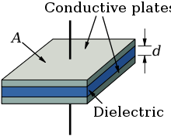 $C=\frac{\text{ε}\text{.A }}{d}$
Where ε = permittivity of the separating material inside the capacitor
A = area of the plates
D = distance between the plates

- If an insulator (or dielectric) of permittivity $ε$ is inserted between the plates, the value of capacitance $C_{d}$, will b$e C_{d}=\frac{εA}{d}$
If we divide $C_{d}$ by $C$ we get $\frac{Cd}{C}=\frac{ε}{ε_{0}}$ which is called the relative permittivity ε_{r} or dielectric constant.
As ε_{r} $=\frac{ε}{ε_{0}}$we can say that ε = $\text{ε}\text{0}\text{ε}\text{r}$
We also have $C_{d}= \text{ε}\text{r} C$

- When capacitors are connected in parallel, the equivalent capacitance is:
C_{p} = C₁ + C₂ + C₃
- When capacitors are connected in series, the equivalent capacitance is:
$\frac{1}{C_{S}}=\frac{1}{C1}$ + $\frac{1}{C2}$ + $\frac{1}{C3}$

Methodology:
Part 1: Capacitance and dielectrics $C_{d}= \text{ε}\text{r} C_{0}$ ($C_{0}$ is the capacitance in free space).
  - Run the simulator the same way as you did in Lab3.
(Click on https://phet.colorado.edu/en/simulations/capacitor-lab
Choose “Run CheepJ Browser-Compatible Version”).

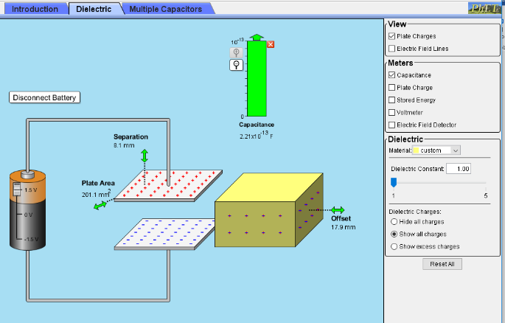

  - Click the “Dielectric” tab on the menu
  - Adjust the plate area and separation distance. Once the area and distance is fixed, do not change it for Part 1. Make sure that the dielectric substance is outside of plates.
  - Determine the value of and compare it to the value from the simulator.

  - Insert the dielectric substance inside the capacitor plates, make sure it’s completely inserted, this should be indicated by the offset being 0.
  - Change the dielectric constant $\text{ε}\text{r}$ and record the capacitance in the following table:

C₀ = F
Trial | Dielectric Constant  $$\text{ε}\text{r}$$ | Capacitance (F)  C
1
2
3
4
5
6

  - In Excel, draw the graph of $\text{ε}\text{r}$ and C, copy and paste your graph below:

  - Calculate the gradient of the above graph:

  - Determine C₀ from the gradient:

  - Calculate percentage error in C₀ by comparing what you get in 1.9 with the calculated one in 1.4:

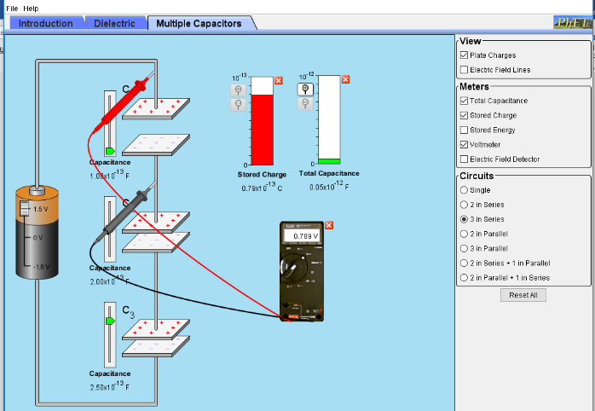
Part 2: Serial connections:

2.1 Click “Multiple Capacitors” tab.
2.2 Click on “3 in series” button.
2.3. Move the voltage slide to maximum and measure the voltage across the battery with the voltmeter Vmax=………………………..V.
2.4 Change the settings on the 3 capacitors to : C₁= 1pF, C₂= 2pF, C₃= 2.5pF as shown in the screenshot above.
2.5 Now measure the voltage across each capacitor.
V1= ______ V2=_____ V3=____
  - What is the relationship of the voltage:

2.7 Use the stated capacitance (1.0x10⁻¹³ F, 2.0x10⁻¹³ F, 2.5x10⁻¹³ F) find the charge on each
capacitor. q₁=____ q₂=____ q₃=____
2.8 Comment on your results of the stored charge with q1, q2, and q3

2.9 What is the total capacitance in Farad? Read the meter:

2.10 Use the formular to find out the total capacitance and compare with meter reading:

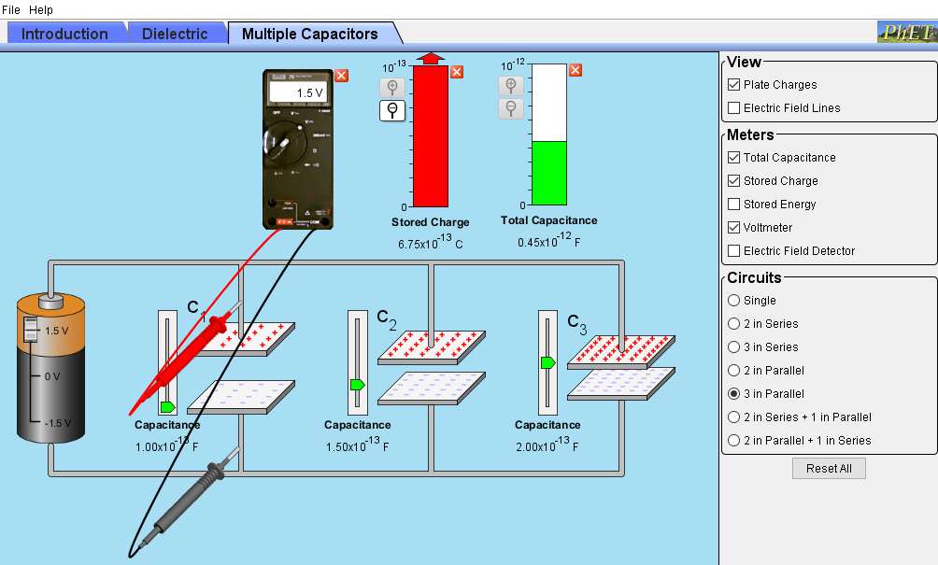
Part 3: Parallel connections:

3.1 Click “Multiple Capacitors” tab.
3.2 Click on “3 in parallel” button.
3.3. Move the voltage slide to maximum and measure the voltage across the battery with the voltmeter Vmax=………………………..V.
3.4 Change the settings on the 3 capacitors to : C₁= 1pF, C₂= 2pF, C₃= 2.5pF as shown in the screenshot above.
3.5 Now measure the voltage across each capacitor. V1=______ V2=_____ V3=____
  - What is the relationship of the voltage:

3.7 Use the stated capacitance (1.0x10⁻¹³ F, 2.0x10⁻¹³ F, 2.5x10⁻¹³ F) find the charge on each
capacitor. q₁=____ q₂=____ q₃=____
3.8 Comment on your results of the stored charge with q1, q2, and q3

3.9 What is the total capacitance in Farad? Read the meter:

3.10 Use the formular to find out the total capacitance and compare with the meter reading:

