Name:
Date: Fri 27-01-2023 to Fri 03-02-2023 at 5:00 pm GMT
- Experts say older people were happier and healthier in the past because they did more exercise and spend more time with their family and friends whereas now many suffer loneliness and health problems.
What are the causes of this and what are some solutions?
Write here:

- The graph gives information about the age of the population of Iceland between 1990 and 2020.
Summarise the information by selecting and reporting the main features and make comparisons where relevant.
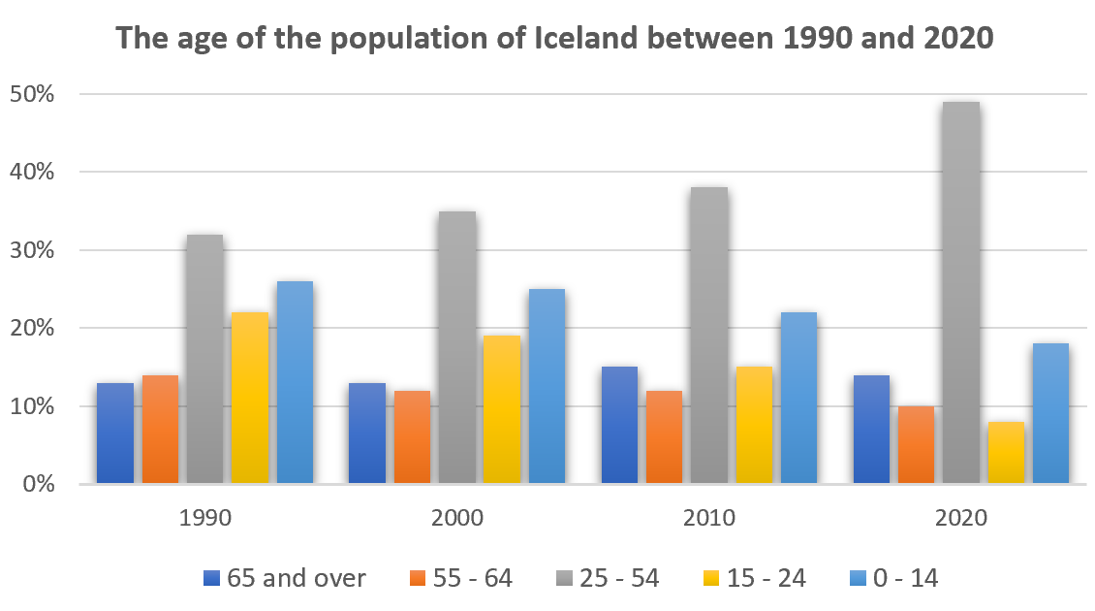

Write here:

