Name:
Date: Fri 03-02-2023 to Fri 10-02-2023 at 5:00 pm GMT
- Some people think that children should be homeschooled when they are very young while others think it is better for them to attend a kindergarten.
Discuss both views?
Write here:

- The pie charts compare ways of accessing the news in Canada and Australia.
Summarise the information by selecting and reporting the main features and make comparisons where relevant.

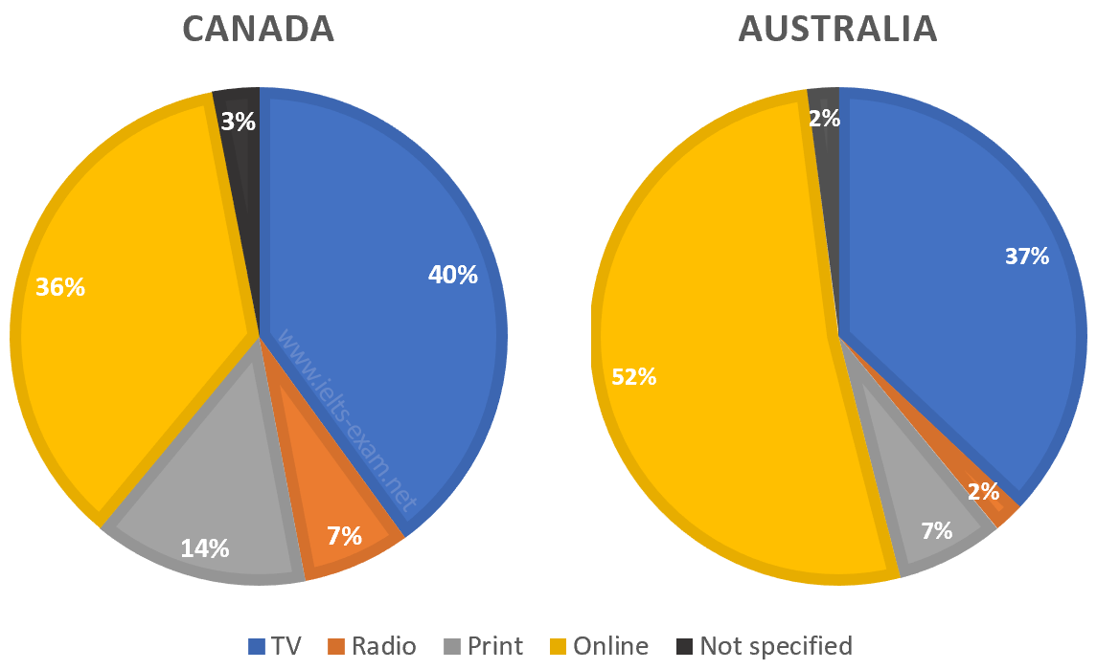

Write here:

