Name:
Date: Fri 20-01-2023 to Fri 27-01-2023 at 5:00 pm GMT (2 Que)
- Although several studies prove that cars are one of the main reasons of environmental pollution, some people claim that there are more disadvantages of the car than its advantages.
Do you agree or disagree? Discuss the advantages and disadvantages of having a car.
Write here:

- The graph below shows the proportion of four different materials that were recycled from 1982 to 2010 in a particular country.
Summarise the information by selecting and reporting the main features and make comparisons where relevant.
Write at least 150 words.

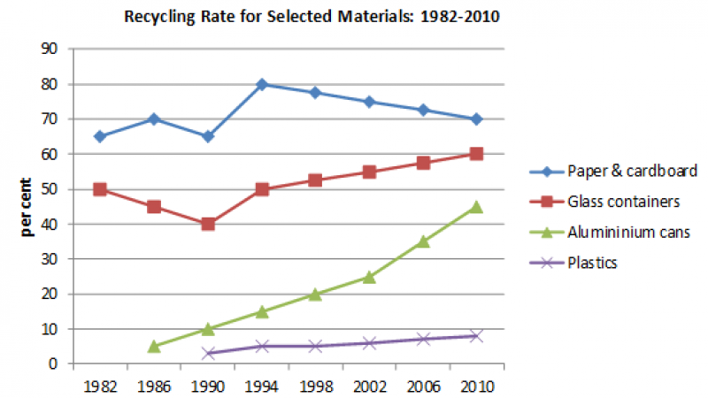

Write here:

